Master

Account Executive Master
This function is to define Account Executive’s information.
Menu: Master → Account Executive
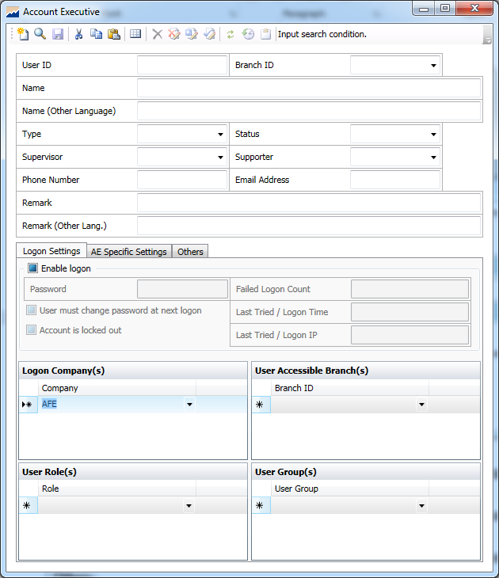
Figure 1: Master → Account Executive

General Setting
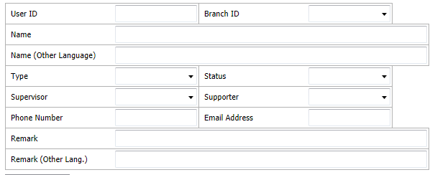
Figure 2: General Setting

Field | Description
*User ID | Unique ID representing user
*Branch ID | Unique ID representing branch  Support to set System Default value.
*Name | Name of the AE
Name (Other Language) | Name of the AE in other language
*Type | AE/Staff
*Status | Activated/ deactivated  Support to set System Default value.
Supervisor | ID of AE’s Supervisor
Supporter | ID of AE’s Supporter
Phone Number | Phone Number of AE
Email Address | Email Address  Validation: Must contain @ and .
Remark | Free text description for additional information
Remark (Other Lang.) | Free text description for additional information in other language
* Mandatory Fields

Logon Settings
User can define AE’s right and permission in accessing company system, branch system, user group system, etc.
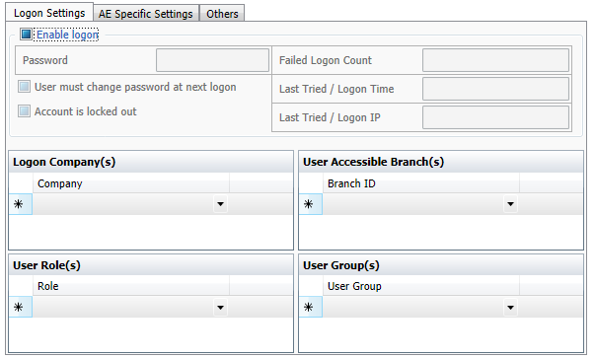
Figure 3: Logon Settings

Field | Description
Enable logon | Check to enable AE to access the system
Password | Password to gain admission
Failed Logon Count | Number of logon failure
Last Tries/ Logon Time | Logon Time of Last Tries
Last Tried/ Logon IP | Logon IP of Last Tries
User must change password at next logon | Require user to change password at next logon
Account is locked out | Account is locked out
Logon Company(s) | Company(s) that AE can log into
User Role(s) | User Role(s) that AE can access
User Accessible Branch(s) | Branch(s) that AE can access
User Group(s) | User Group(s) that AE can access

AE Specific Settings
A user can set AE’s Commission Rebate, exposure limit, or set as black list in this function.
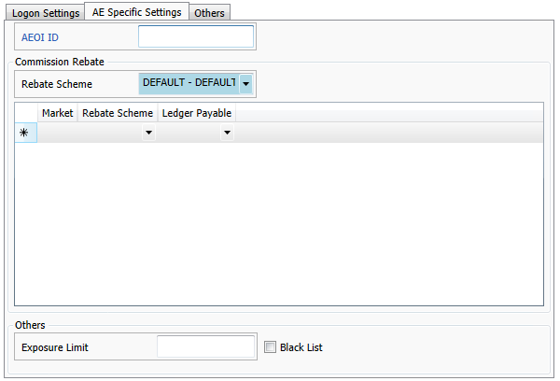
Figure 4: AE Specific Settings

Commission Rebate
AEOI ID | ID of Automatic Exchange of Financial Account Information
*Rebate Scheme | Rebate Scheme for AE  Support to set System Default value.
Market | Market
Ledger Payable | The financial account types the commission belongs to
Others
Exposure Limit | AE’s trading limit
Black List | Put on a blacklist

* means Mandatory

Others
User may modify AE own Account List, General – Central Entity Number, Message to Client and Message to Client (Other Language) depending on business needs.
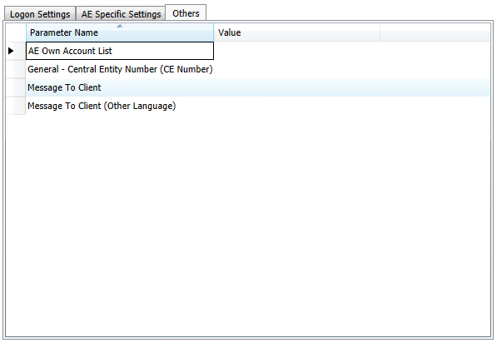
Figure 5: Others

Account Status Code Master
User can update, create or revoke account status on “Account Status Code Master”.
Define the account status code, name and choose the action(s) by checking the checkbox(es) below, user can execute the status code when account status is being used.
Menu: Master → Account Status Code
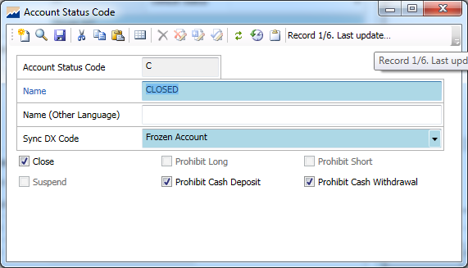
Figure 6: Master → Account Status Code

Field | Description
Account Status Code | Account Status Code
Name | Name of Account Status
Name (Other Language) | Name of Account Status in other language

Account Type Master
Menu: Master → Account Type
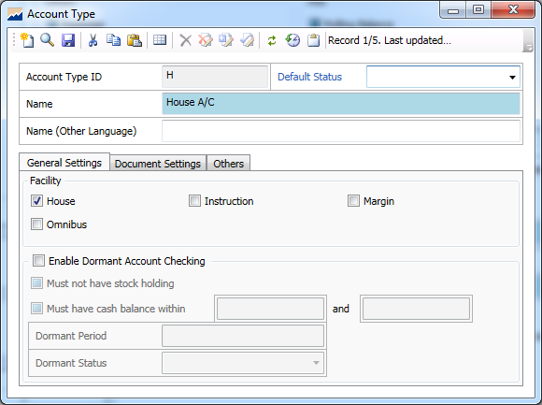
Figure 7: Master → Account Type

Account Class Master
User can classify Account with an aim to suit user’s business need, user can set up several account classes inheriting in one default account type. It can be used for sorting clients with classes, i.e. Normal, VIP, and margin, to offer different margin trading services or interest settings.

Menu: Master → Account Class
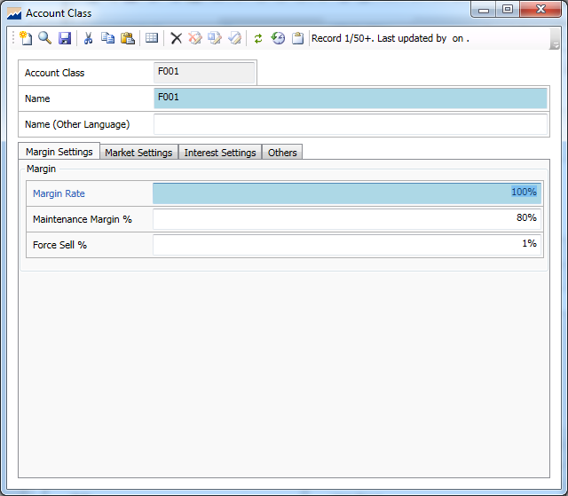
Figure 8: Master → Account Class

General Settings
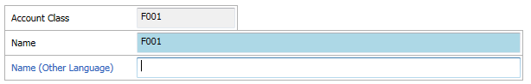
Figure 9: Account Class - General Setting

In General Settings, user may fill in the basic information of the account class.
Field | Description
Account Class | Unique code representing account class (shown in database)
Name | Name of the account class (shown in front office)
Name (Other Language) | Name of the account class in other language

Margin Settings
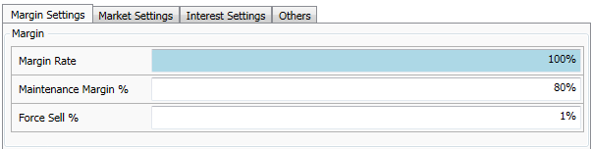
Figure 10: Account Class - Margin Setting

Field | Description
Margin Rate | Ratio of allowed margin trading
Maintenance Margin % | The minimum amount of equity that must be maintained in a margin account
Force Sell % | An indicator ratio to force to liquidate investor’s holding

Market Settings
Markets specific settings can be overridden in Account Class level, such as Rebate Scheme, Merge Trade, Liquidation Sequence, Fee Settings and Margin Rate.
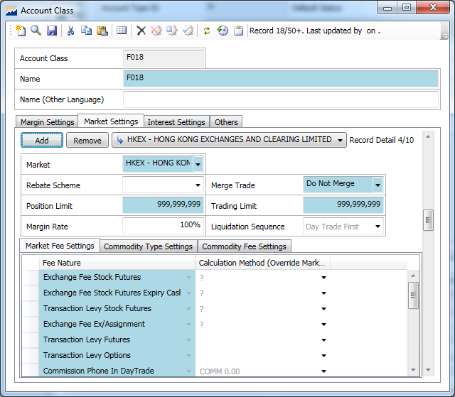
Figure 11: Account Class - Market Settings

Field | Description
*Market | Market
Rebate Scheme | Rebate scheme for AE
*Merge Trade | how the account contracts are merged  Support to set System Default value.
Position Limit | Maximum Position Limit
Trading Limit | Maximum Trading Limit
Margin Rate | Ratio of allowed margin trading
Liquidation Sequence | Liquidation Logic  Example: Day Trade First, First in First out

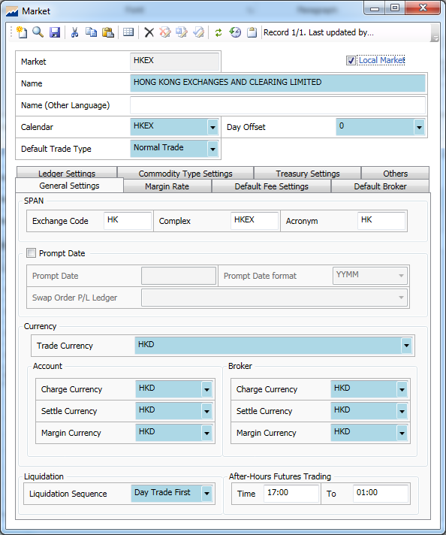
Figure 12: Master → Market

^Note: Default Account Market can be set on Company Master.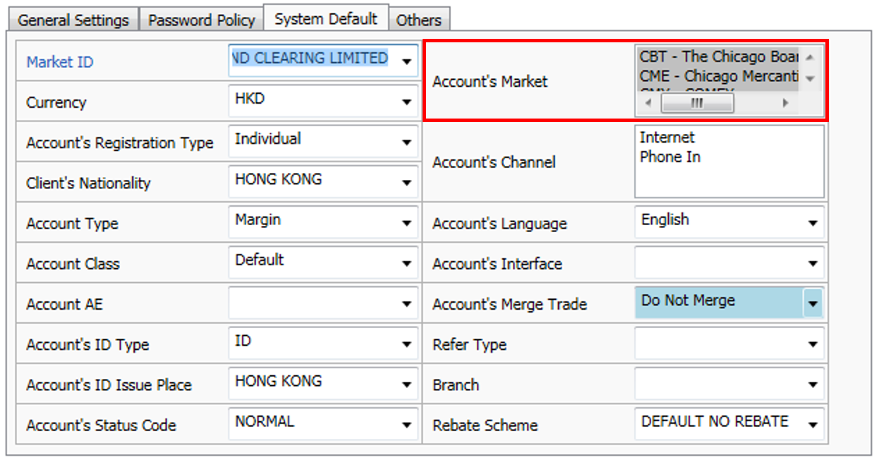
Figure 13: Master → Company (System Default)

Commodity Fee Settings
At “Commodity Fee Settings” tab, it displays fee nature, transaction type and calculation method (override Commodity Master).
Note: User may go to Fee Nature Master to retrieve or amend detailed settings by holding <Ctrl> + clicking on the Market Settings page or opening from menu.

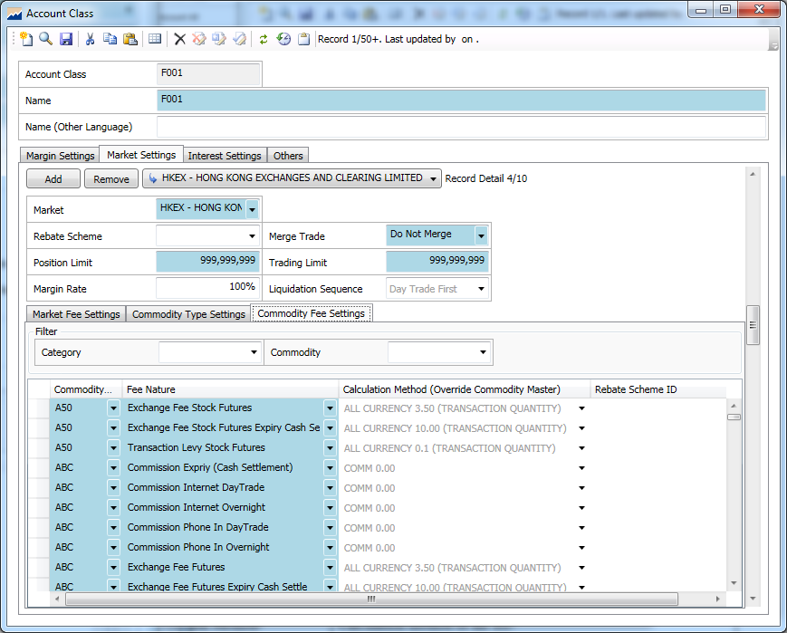
Figure 14: Account Class Commodity Fee Setting

Field | Description
Commodity Code | The Code for Commodity
Fee Nature | Fee type
Calculation Method | Calculation method of the fee  Can be defined in Calculation Method Master
Rebate Scheme ID | Calculation method of the Rebate

Interest Settings
User can modify interest setting (Interest Currency, Calculation Method …)
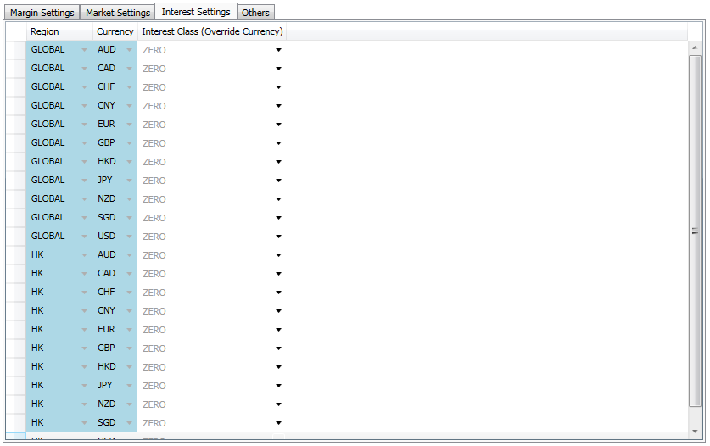
Figure 15: Account Class Interest Settings

Field | Description
Region | Region
Currency | Currency
Interest Class (override Currency) | Interest Class

Bank Master
Menu: Master → Bank
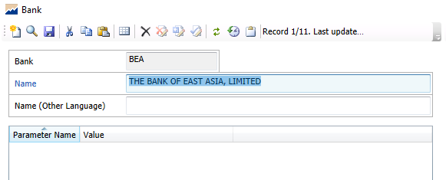
Figure 16: Master → Bank

Field | Description
Bank | Bank ID
Name | Name of the bank
Name (Other Language) | Name of the bank in other language

Bank Account Master
User can define a specific bank account number in Bank Account Master.
Menu: Master → Bank Account
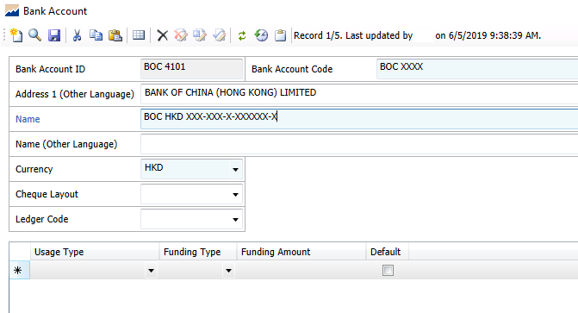
Figure 17: Master → Bank Account

Field | Description
Bank Account ID | Bank Account ID
Bank Account Code | Bank
Name | Name of the bank
Name (Other Language) | Name of the bank in other language

Branch master
User can define the basic branch details including the address of the branch, phone/ fax number, email and who is the account executive (or person in charge) of a particular branch.
Menu: Master → Branch

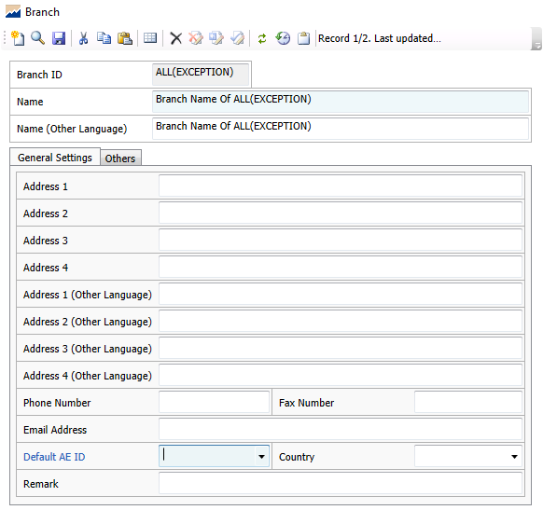
Figure 18: Master → Branch

Broker Master

Menu: Master → Broker
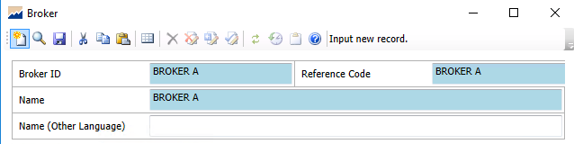
Figure 19: Master → Broker

Field | Description
Broker ID | Broker ID
Reference Code | Reference Code (User may input broker ID here if there is no specific reference code for the broker)
Name | Name of the broker
Name (Other Language) | Name of the broker in other language

General Settings
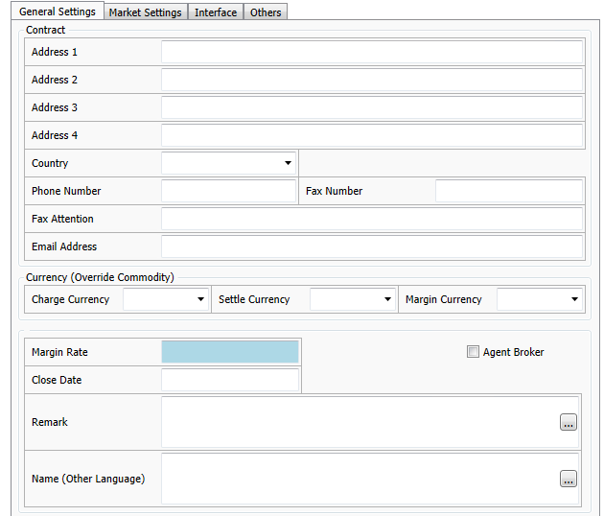
Figure 20: General Settings in Broker Master
In General Settings > Contact section, user may fill in the basic information of the broker.
Field | Description
Address Line 1 - 4 | Address of the broker firm
Country | Country of the broker
Phone Number | Phone number of the broker
Fax Number | Fax number of the broker
Fax Attention | The fax attention person
Email Address | Email address of the broker
Charge Currency | Dropdown list of charge currency
Settle Currency | Dropdown list of settle currency
Margin Currency | Dropdown list of margin currency
Margin Rate | The margin ratio for the broker
Close Date | The close down (or termination) date of the broker
Remark | Maximum 130 characters
Name (Other Language) | The name in other language
Agent Broker | Tick this checkbox if the broker is an agent of your company

In General Settings > Currency section, user can define the charge currency, settle currency and margin currency. And the setting in broker master would override that in commodity master (as marked in red below).
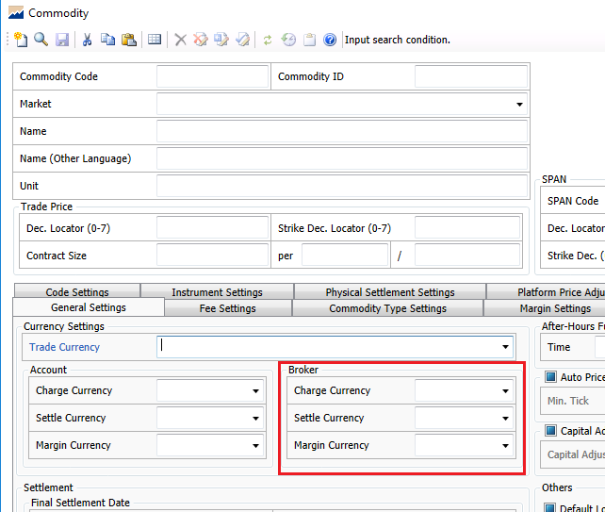
Figure 21: Currency setting in Commodity Master

Market Settings

Fee Settings
In Market Settings > Fee Settings tab, add the corresponding market, e.g. HKEX, and the fee settings will be populated according to the records from Market Master.
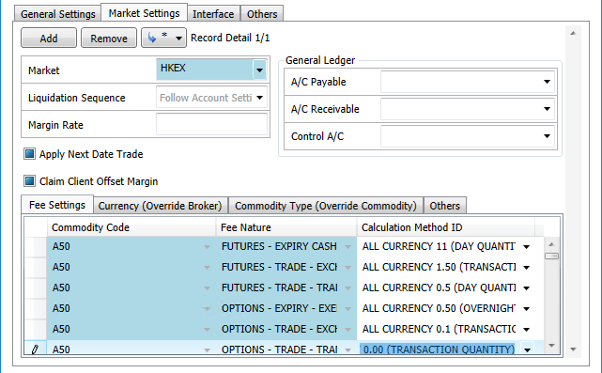
Figure 22: Fee settings in Broker Master

Currency
In Market Settings > Currency tab, user can define the currency for particular commodities. This will override the settings in general settings of broker master.
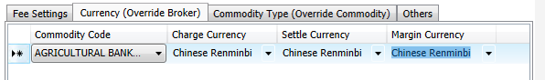
Figure 23: Currency settings in Broker Master

Commodity Type
In Market Settings > Commodity Type tab, user can define the margin type for different commodity type. And this setting will override that in Commodity Master.
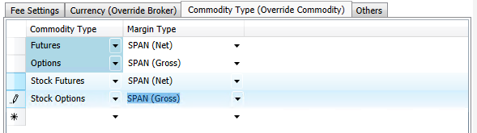
Figure 24: Commodity Type setting in Broker Master

Others
This is the system parameter for Broker Master.
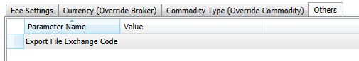
Figure 25: Export File Exchange Code Setting in Broker Master

Interface
This is the system parameter for Broker Master.
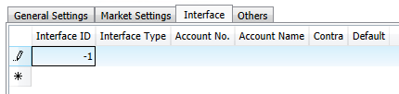
Figure 26: Interface setting in Broker Master

Others
This is the system parameter for Broker Master.
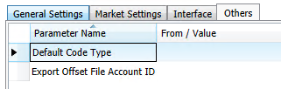
Figure 27: Others setting in Broker Master

Calendar Master
User can define the public holiday by different trade markets in Calendar Master.
Menu: Master → Calendar
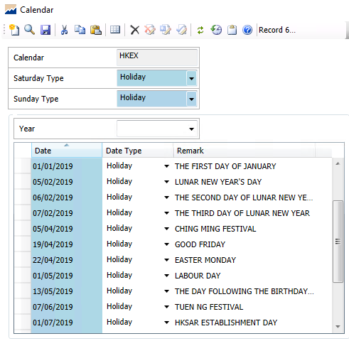
Figure 28: Master → Calendar

Cheque Layout Master

Print Cheque Layout can be adjusted by changing the value of Position (X), and Position (Y) of the Elements (e.g. Payee, Cheque Amount).
Menu: Master → Cheque Layout
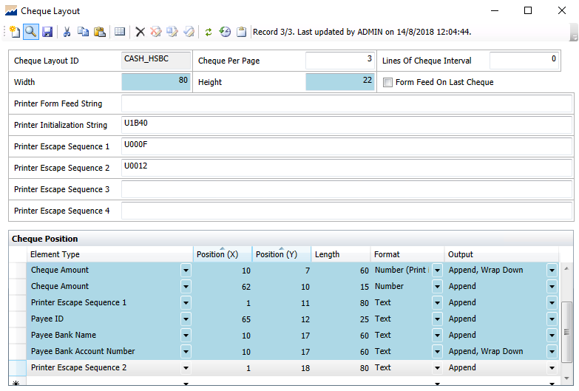
Figure 29: Menu: Master → Cheque Layout

Company Master
Menu: Master → Company
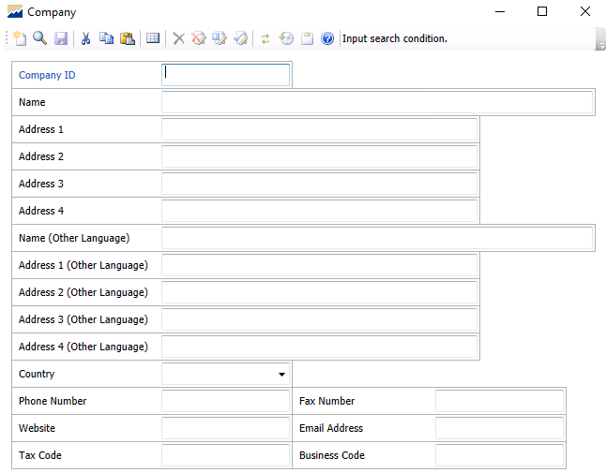
Figure 30: Master → Company Master

Field | Description
Company ID | Company ID
Name | Name of the company
Address Line 1 – 4 | Address of the company
Name (Other Language) | Name of the company in other language
Address Line 1 – 4 (Other Language) | Address of the company in other language
Country | Country
Phone Number | Company phone number
Fax Number | Company fax number
Website | Company website
Email Address | Company email address
Tax Code | Tax code of the company
Business Code | Business code of the company

General Settings
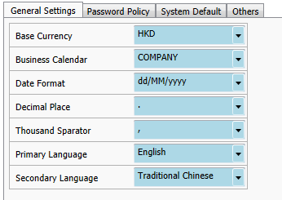
Figure 31: General Settings in Company Master

Field | Description
Base Currency | This currency will be used in displaying in reports and statements for all clients.
Business Calendar | User can set the business calendar (where the calendar can be defined in Calendar Master), and the system date will be rolled (skipping the holiday) by referencing to this calendar.
Date Format | This defines the date format used throughout the G3FB system.
Decimal Place | This defines the punctuation used in displaying decimal place.
Thousand Separator | This defines the punctuation used in displaying every thousand numbers.
Primary Language | The default display language
Secondary Language | The secondary language

Password Policy
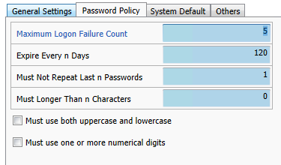
Figure 32: Password policy in Company Master

Field | Description
Maximum Logon Failure Count | Login account is locked out after X number of trials.
Expire Every n Days | Password will be expired every n days.
Must Not Repeat Last n Passwords | New password cannot be the same as the last n passwords.
Must Longer Than n Characters | Password has to be longer than n characters.

System Default

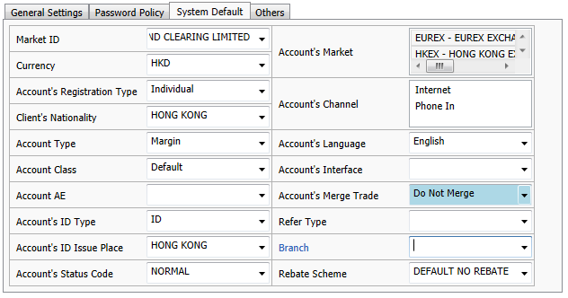
Figure 33: System Default in Company Master

User can define the default setting for the following fields:
Field | Description
Market ID | Default market
Currency | Default settle currency
Account’s Registration Type | Default registration type in Account Master
Client’s Nationality | Default nationality in Client Master
Account Type | Default account type in Account Master
Account Class | Default account class in Account Master
Account AE | Default AE ID in Account Master
Account’s ID Type | Default ID type in Client Master
Account’s ID Issue Place | Default ID issue place in Client Master
Account’s Status Code | Default status code in Account Master
Account’s Market | Default account’s market
Account’s Channel | Default order placing channel in Account Master
Account’s Language | Default account’s language
Account’s Interface | Default cash interface type in Account Master > Currency Settings
Account’s Merge Trade | Default merge trade method, merge by same price, or same channel, or both; or do not merge in Account Master > Market Settings
Refer Type | Default refer type in Account Master > Rebate section
Branch | Default branch in Account Master
Rebate Scheme | Default rebate scheme Account Master > Rebate section

Others
Here user can find a list of company parameters for different modules in system.
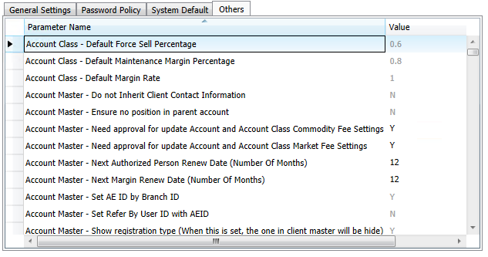
Figure 34: Company Parameters

Contact Report
AFE would help configure the contact report information. And user can edit the details afterwards.

Menu: Master → Contact Report
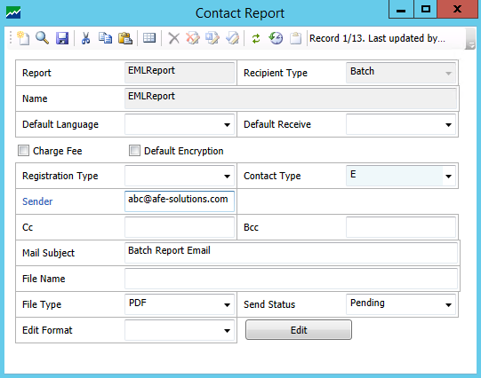
Figure 35: Master → Contact Report

Contact Report Template
User can create the contact report template.

Menu: Master → Contact Report Template
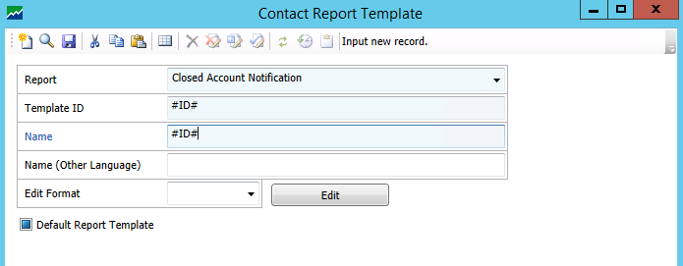
Figure 36: Master → Contact Report Template

Country Master
Menu: Master → Country
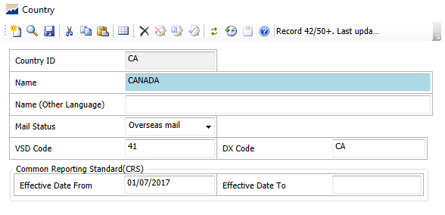
Figure 37: Master → Country

Field | Description
Country ID | Country ID
Name | Name of the country
Name (Other Language) | Name of the country in other language
Mail Status | Mail status
VSD Code | VSD Code
DX Code | Data exchange code for front office
Effective Date From | This indicates the ‘effective date from’ of Common Reporting Standard (CRS)
Effective Date To | This indicates the ‘effective date to’ of Common Reporting Standard (CRS)

Currency Master
Menu: Master → Currency Master
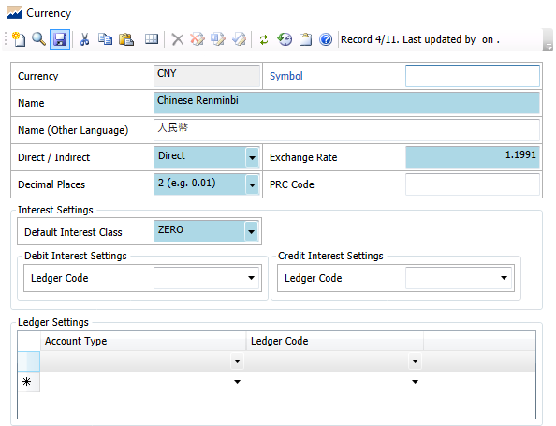
Figure 38: Master → Currency Master

General Settings

Field | Description
Currency | Currency ID
Name | Name of the currency
Name (Other Language) | Name of the currency in other language
Direct/ Indirect | The calculation method of exchange rate.  Direct represents using the exchange rate (x) input by user.
Exchange Rate | The calculation method of exchange rate.  Indirect represents using the inverse of exchange rate (1/x) input by user.
Decimal Places | The decimal places used in currency
PRC Code | PRC Code

Interest Settings
User can define the default interest class, where the interest class can be set in Interest Class Master.
And here user can define the ledger code for debit and credit interest.

Ledger Settings
User can set the ledger code for different account types, e.g. cash account, margin account etc.

Custodian Bank
User can define the custodian bank here and it will appear in Account Master > Market Settings > Account Custodian.
Menu: Master → Custodian Bank
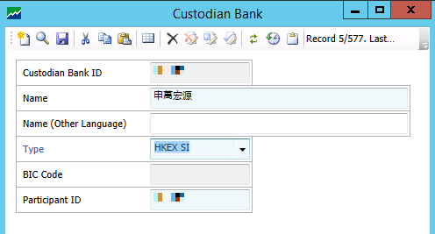
Figure 39: Master → Custodian Bank

Document Master
User can set the document type in Document Master, where this document type will be displayed in the drop-down list in Account Master > Document Settings > Document.

Menu: Master → Document
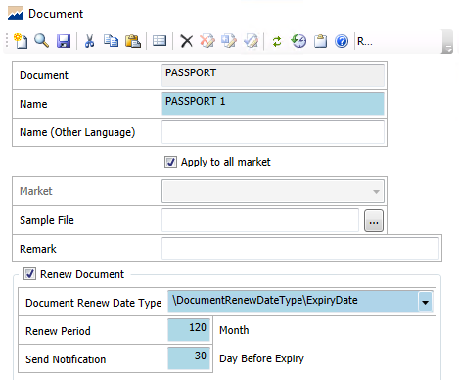
Figure 40: Master → Document

Field | Description
Document | Document ID
Name | Name of the document
Name (Other Language) | Name of the document in other language
Market | Document which specific to a certain market
Sample File | User can attach a sample file for internal reference.
Remark | Additional information
Document Renew Date Type | Upon ticking Renew Document, field will be enabled.  This allows user to supplement the document renew type by Expiry Date or Renewal Date.
Renew Period | Upon ticking Renew Document, field will be enabled.  This allows user to input the renew period of the document.
Send Notification | Upon ticking Renew Document, field will be enabled.  Notification will be sent out x day before expiry.

Exchange Rate Master
User can define sets of exchange rate for different purposes in system.

Menu: Master → Exchange Rate
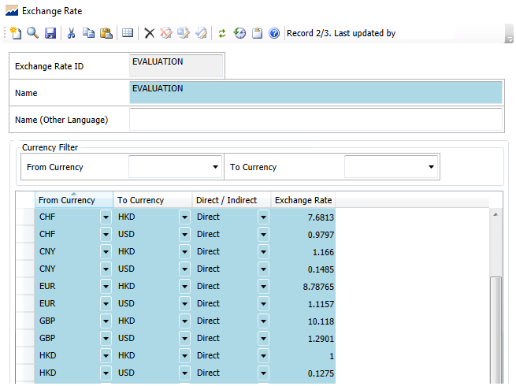
Figure 41 Master → Exchange Rate

In this page, user can define the currency from and to and its corresponding exchange rate.
User can set to use this exchange rate by direct calculation, i.e. the conversion is using the rate directly; or by indirect calculation, i.e. the conversion is calculated by an inverse value of the exchange rate.

Here below are some suggestions for setting different sets of exchange rate:
- Evaluation can be used for the general rate setting in G3SB system.
- HKEX can be used for the calculation of stamp duty.
- Ledger can be used for accounting use.
- CRS can be used for common reporting standard.

Hot Key
User can create hot key for functions that are frequently used.

Menu: Master → Hot Key
Method 1
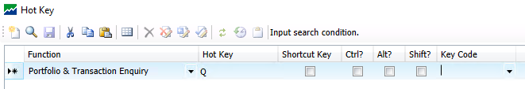
Figure 42: Master → Hot Key (Method 1)

Input the hot key at the field marked red below. And the function Portfolio & Transaction Enquiry will be popped out.
Figure 43: Hot Key

Method 2
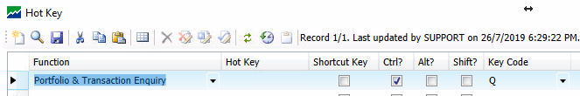
Figure 44: Master → Hot Key (Method 2)

Input your key code with Ctrl, Alt or Shift. In the above example, the function Portfolio & Transaction Enquiry will be popped out when user click ‘Ctrl’ + ‘Q’.

Instrument

Menu: Master → Instrument
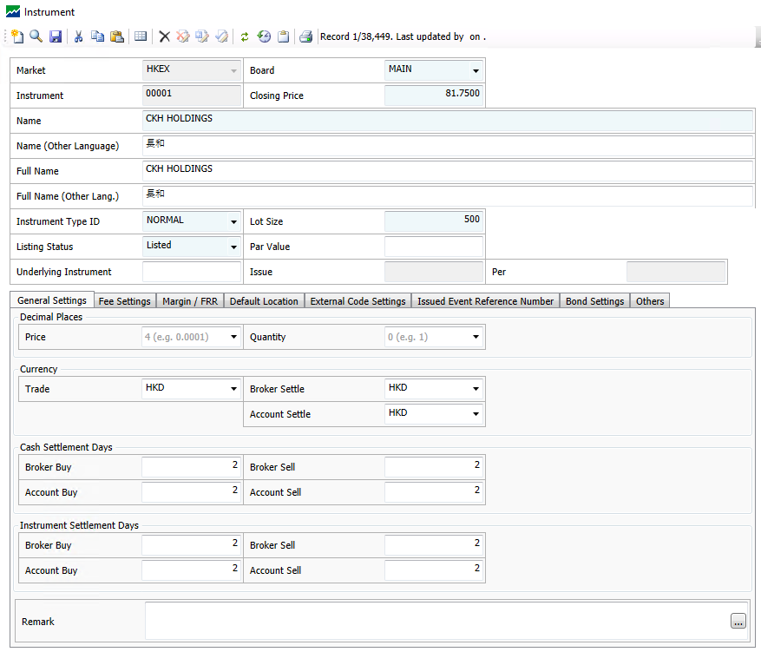
Figure 45: Master → Instrument
Field | Description
Market | The market that this instrument belongs to
Board | The board that this instrument belongs to
Instrument | Stock code
Closing Price | The closing price of the instrument
Name / Full Name | Name of the stock
Name / Full Name (Other Language) | Name of the stock in other language
Instrument Type ID | Whether it is a bond, CBBC, ETF, GEM etc.
Lot Size | Lot Size
Listing Status | Whether the company is listed or not
Par Value | Face value of a bond / stock value
Underlying Instrument | An instrument whose value determines the value of a derivative investment or product
Issue/ Per | For CBBC products

General Settings

Field | Description
Decimal Places – Price | Define the decimal places of the stock price
Decimal Places - Quantity | Define the decimal places of the number of shares
Currency – Trade / Broker Settle / Account Settle | Define the currency for trade and settlement
Cash Settlement Days | Define the number of days to settle cash at broker or account side
Instrument Settlement Days | Define the number of days to settle instrument at broker or account side

Fee Settings
Please refer to G3SB HK User Guide-Fee Settings.

Margin / FRR
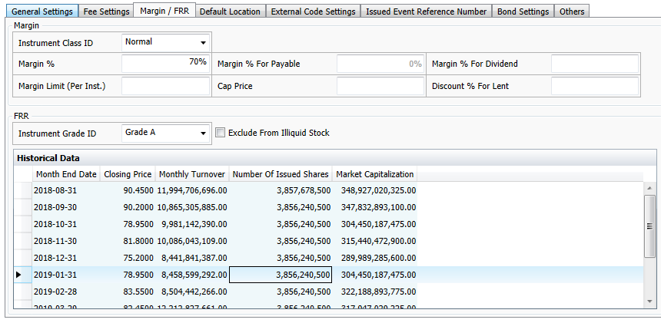
Figure 46: Margin / FRR

Field | Description
Margin | Please refer to G3SB HK User Guide-Margin Management.
FRR – Instrument Grade ID | Define the Instrument Grade ID for the instrument. (which is pre-set at Instrument Grade ID Master)
Historical Data | This section will display the closing price, turnover, number of issued shares and market capitalization at every month end.

Default Location
User can set the default CCASS account for the instrument.

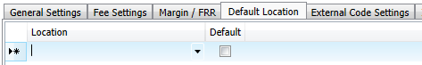
Figure 47: Default Location

Bond Settings
When the instrument type is ‘bonds’, fields in Bond Settings will be enabled.
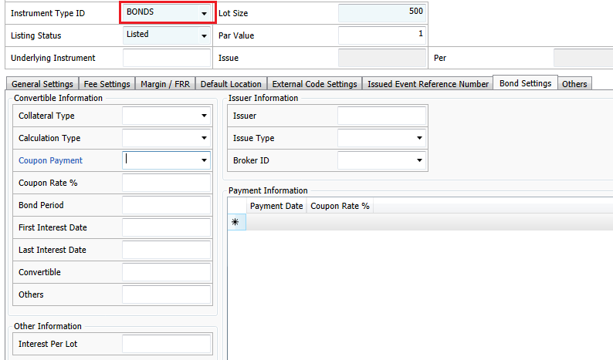
Figure 48: Instrument Master → Bond Settings
Field | Description
Collateral Type | Define whether it is corporate guaranty or by notes.
Calculation Type | Define the calculation type of the bond
Coupon Payment | Define the fixed interval for interest payment
Coupon Rate % | The fixed interest rate paid to the bond holders
Bond Period | The date to bond mature
First Interest Date | Date of the first time to receive interest
Last Interest Date | Date of the last time to receive interest
Convertible | Whether it is a convertible bond or not
Others | Additional Information
Interest Per Lot | Interest per lot
Issuer | Bond issuer
Issue Type | The issue type of the bond. E.g. A sovereign bond is a debt security issued by a national government.
Broker ID | The broker of the bond issuer

Payment Information
User can mark the payment date and the corresponding coupon rate here.

Others
User can update the basic information of the instrument like the number of listed shares, market capitalization, risk level etc.
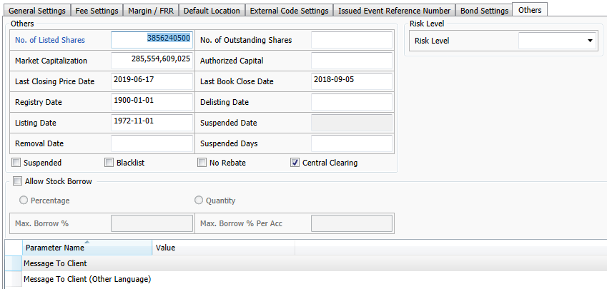
Figure 49: Instrument Master → Others

For stock borrowing and lending modules enabled, user can set the stock to allow borrow and the borrowing percentage.
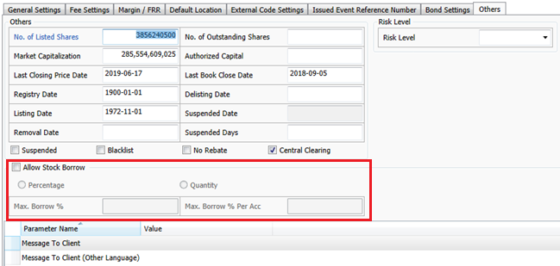
Figure 50: Stock borrowing and lending

Instrument Class
User can define the instrument margin at Instrument Class.

Menu: Master → Instrument Class
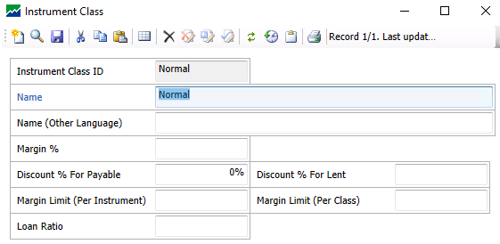
Figure 51: Master → Instrument Class

Field | Description
Instrument Class ID | Instrument Class ID
Name | Name of the instrument class
Name (Other Lang) | Name of the instrument class in other language
Margin % | A margin ratio for instrument that belongs to this class
Discount % For Payable | A discount % for book close payable like entitlement
Discount % For Lent | A discount % for short sell
Margin Limit (Per Instrument) | The maximum margin amount allowed for an instrument
Margin Limit (Per Class) | The maximum margin amount allowed for an instrument class
Loan Ratio | It is the loan to value ratio.

Instrument Grade
User can define the instrument grade, haircut % and instrument.
Menu: Master → Instrument Grade
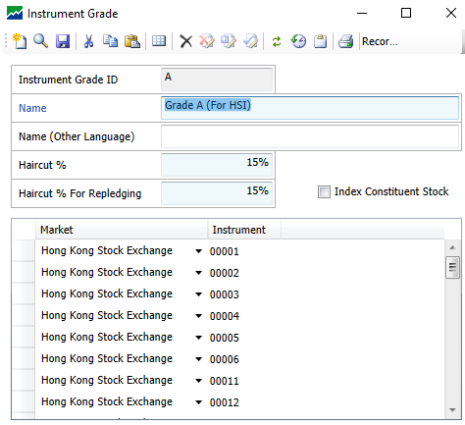
Figure 52: Master → Instrument Grade

Instrument Group
Menu: Master → Instrument Group
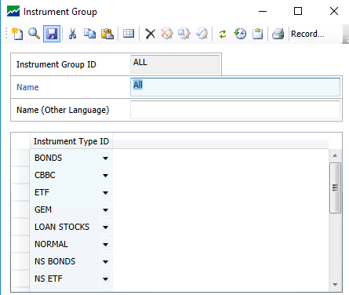
Figure 53: Master → Instrument Group

Instrument Type
User can define different types of instrument, e.g. bonds, CBBC, ETF etc.
Menu: Master → Instrument Type
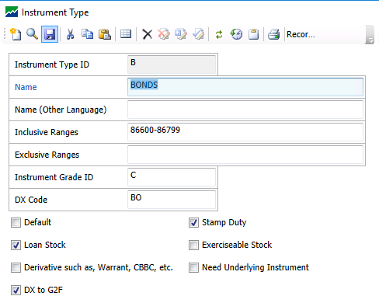
Figure 54: Master → Instrument Type

Note: If there are multiple ranges, please use [,] to separate ranges.

Interest Class
User can set the debit and credit interest in Interest Class Master.
Menu: Master → Interest Class
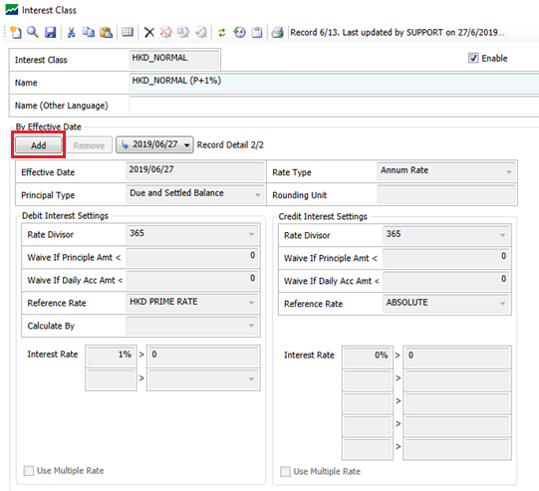
Figure 55: Master → Interest Class

Step 1 Input the interest class ID and name.
Step 2 Click Add and fill in the following mandatory fields as explained below.
Field | Description
Rate Type | Annum Rate/ Daily Rate/ Monthly Rate  Please note to input a correct interest rate as per the rate type defined here.
Principal Type | Define whether to calculate the interest base on balance with / without hold balance
Rate Divisor | It is to define the rate divisor for different rate types.
Reference Rate | Assume we have to set a debit interest P + 1%, define P in Reference Rate Master and  And set the interest rate as 1% as above example.  User may apply multiple interest rate if necessary.

Ledger Master
User can define the ledger for accounting in Ledger Master.

Menu: Master → Ledger
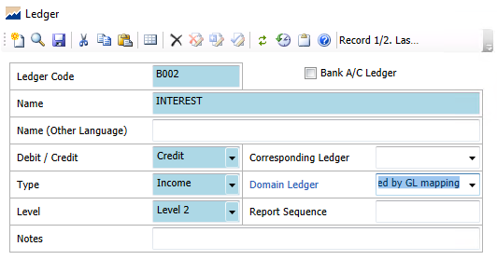
Figure 56 Master → Ledger

In this page, user can set the basic information like whether it is a debit/ credit ledger, ledger type and level.
And this ledger can be clearly referenced by setting the Domain Ledger and Corresponding Ledger.

Location
User can define the CCASS location.

Menu: Master → Location
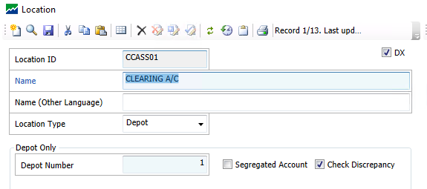
Figure 57: Master → Location

Market
Menu: Master → Market
In this page, user can set the calendar used, the default settlement broker and default trade type when account and broker contract are created. In most cases, default trade type is Normal and default settlement broker is CCASS for HKEX market.

Instrument Settings
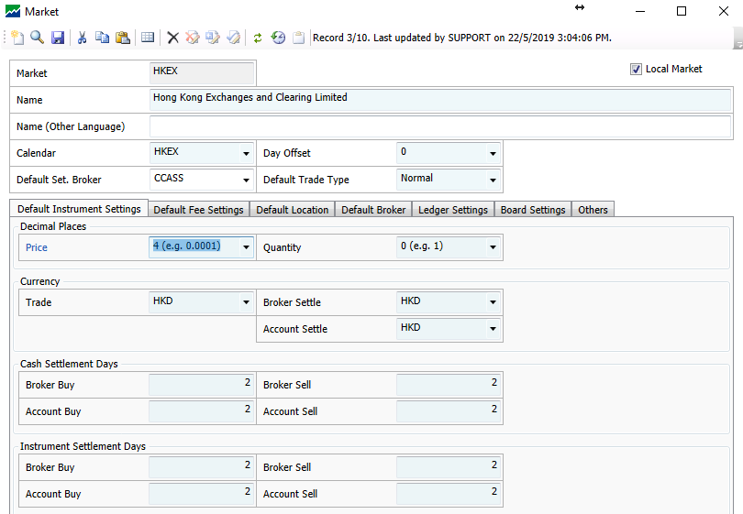
Figure 58: Default Instrument Settings
Field | Description
Decimal Places | Define the decimal places for stock price and number of shares (quantity)
Currency | Define the currency used in Trade, Broker or Account Settlement
Cash Settlement Days | Define the cash settlement days for broker buy/sell, and account buy/sell
Instrument Settlement Days | Define the instrument settlement days for broker buy/sell, and account buy/sell

Fee Settings
User can attach the fee nature and calculation method to Market Master. It will become a default setting to Instrument Master, Account Class Master and Account Master.
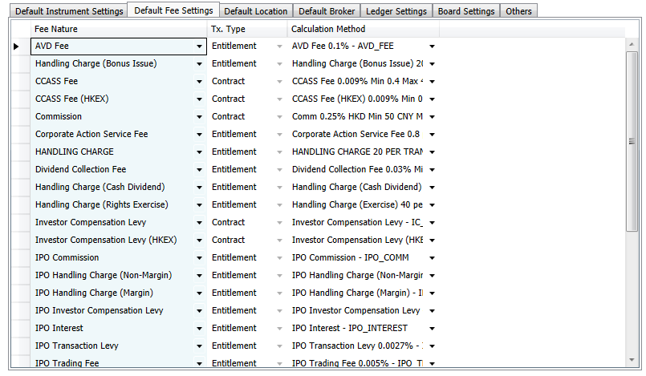
Figure 59: Default Fee Settings

Location
User can link the account type to corresponding CCASS location for the specific market.
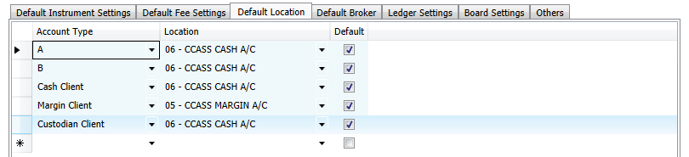
Figure 60: Default Location

Broker
G3SB allows the flexibility for user to define a different broker for outside broker trade. Create Broker Contract Flag means whether to create the broker trade automatically after creating the account trade.
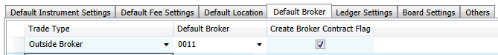
Figure 61: Default Broker

Ledger Settings
User can set the general ledger for different account types.
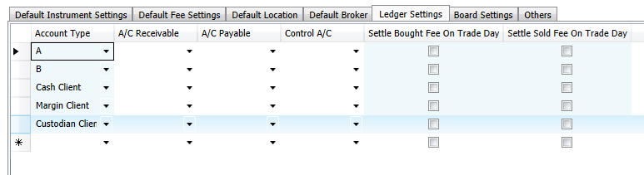
Figure 62: Ledger Settings

Board Settings
User can set the default board for a specific market.
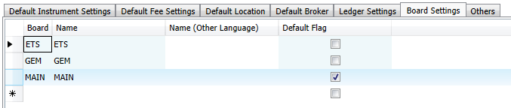
Figure 63: Board Settings

Others
At CCASS Interface, user can set the CCASS information including the clearing and entitlement account, exchange participant ID and market code.
At Do Matching, user can define the contract matching criteria.
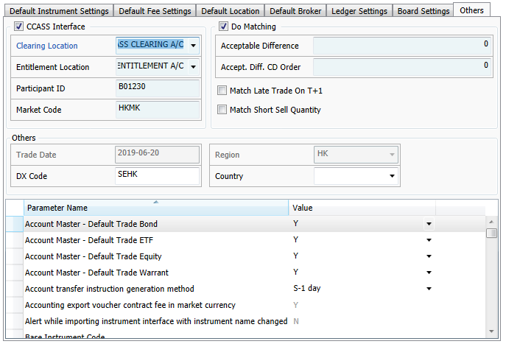
Figure 64: Others

Reference Rate
User can define the prime rate from bank in Reference Rate Master.
Menu: Master → Reference Rate
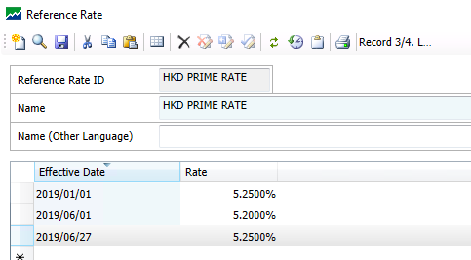
Figure 65: Master → Reference Rate

Region Master
User can define the currency used in the region.
Menu: Master → Region Group
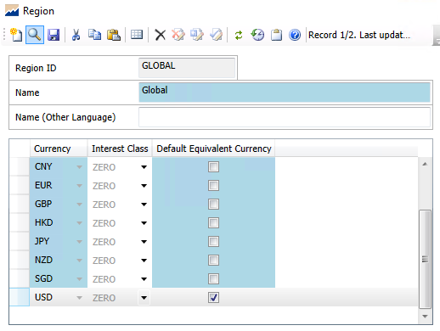
Figure 66 Master → Region Group
Usually there are multiple currencies for global region. In the setting above, currency USD will be used as default for reporting in global region.

Registration Group Master
There are various registration types in Account Master, e.g. individual, joint, house, broker, corporation account etc.
User can group the registration types in below menu:

Menu: Master → Registration Group
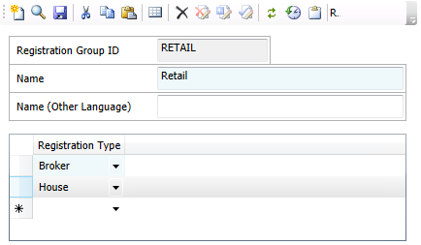
Figure 67 Master → Registration Group

Risk Level
User can define the AML and client risk level in Risk Level Master. And it is used in Client Master > Others and Instrument Master > Others.

Menu: Master → Risk Level
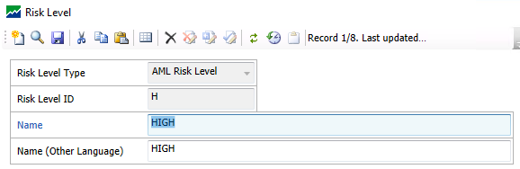
Figure 68: Master → Risk Level

Trade Restriction
User can restrict certain instruments’ buy or sell trade here by adding the instrument without enabling ‘Allow Buy’ or ‘Allow Sell’.

Menu: Master → Trade Restriction
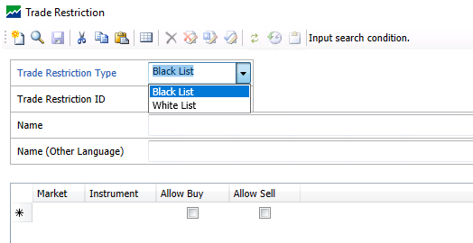
Figure 69: Master → Trade Restriction

Transaction Code Master
Transaction code e.g. CD, CW indicating the movement of cash helps record cash deposit and withdrawal.
Menu: Master → Transaction Code

In “Transaction Code Type” field, select “Account Cash”.
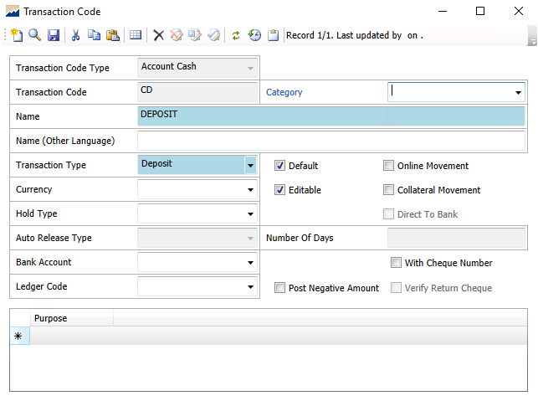  Transaction Code (CD) | 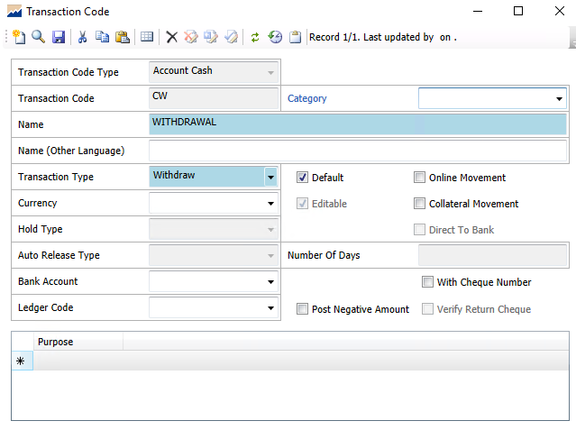  Transaction Code (CW)
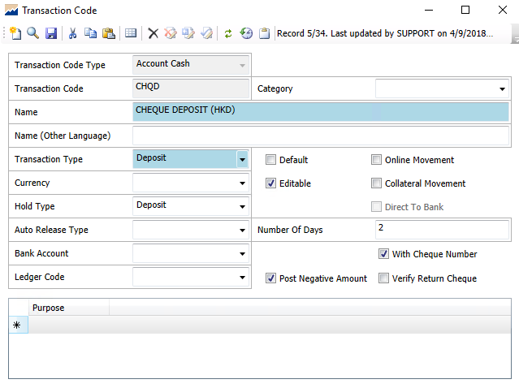
Transaction Code (CHQD)

END OF DOCUMENT

User may go to Market Master to retrieve or amend detailed market settings by holding <Ctrl> + clicking on the Market Settings page or opening from menu.

